**VISUALIZATION TOOL FOR ELECTRIC CHARGE AND RANGE ANALYSIS**

**1. Introduction:**

Visualization tools are programs that create graphical representations of data, allowing for easier analysis and interpretation. A visualization tool for electric charge and range analysis can greatly aid in understanding and predicting the behaviour of electric charges, as well as in designing and optimizing electrical systems.

**Purpose:**

Understanding the electric charge status of a vehicle .A visualization tool can display the current level of charge in a vehicle battery and how much charge is left before it needs to be recharged .This can help drivers plan their trips and make decisions about where and when to recharge their vehicles.

**2. Problem definition and design thinking:**

**Empathy map**

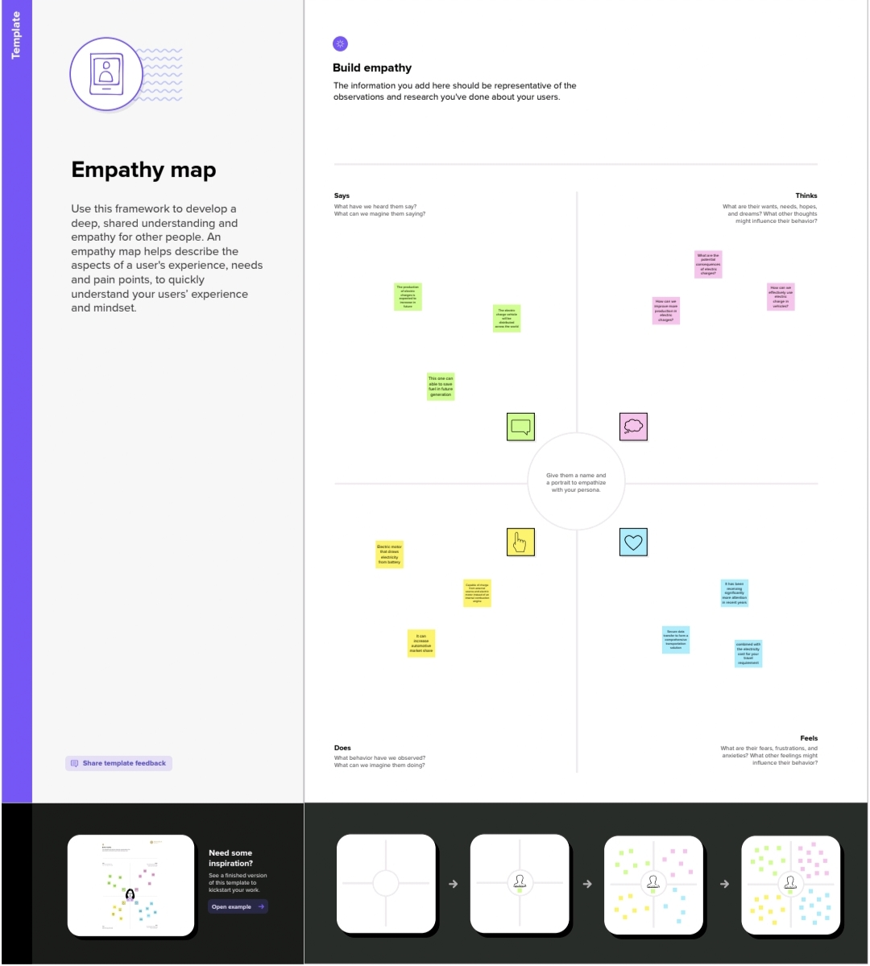

Ideation and brainstorming map

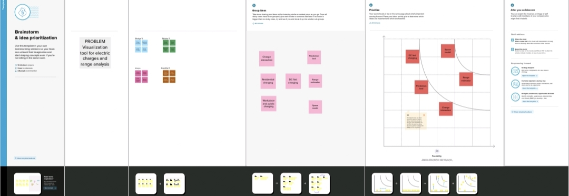

**3. Result:**

The data has been collected and visualized.

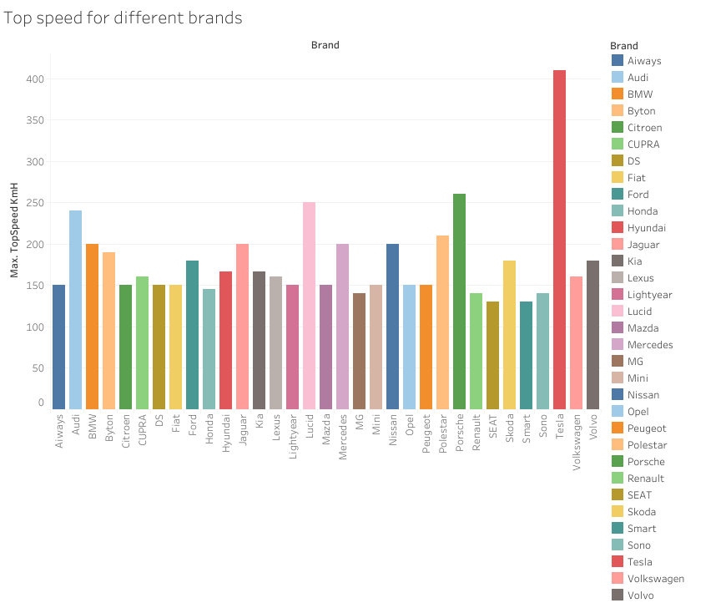

Top speed for different brands

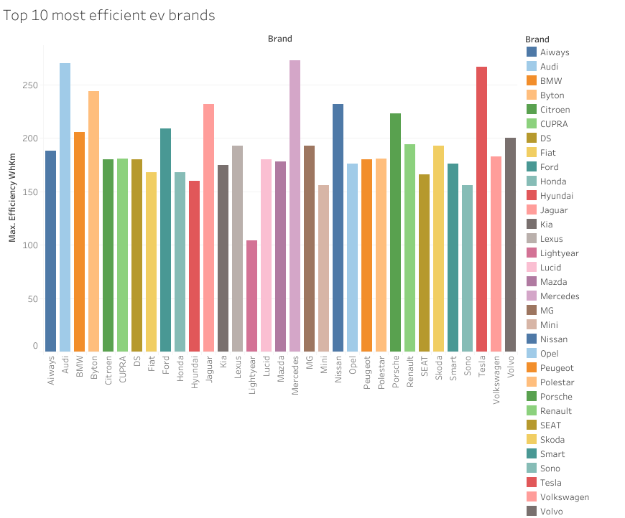

Top 10 most efficient EV brands

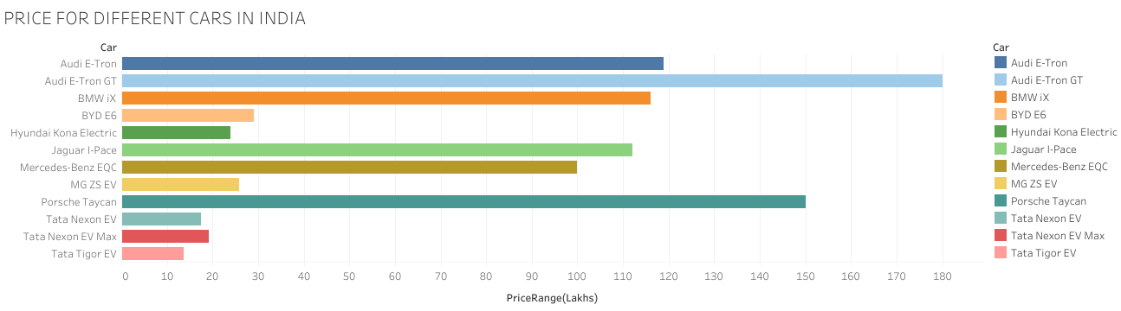

Price for different cars in INDIA

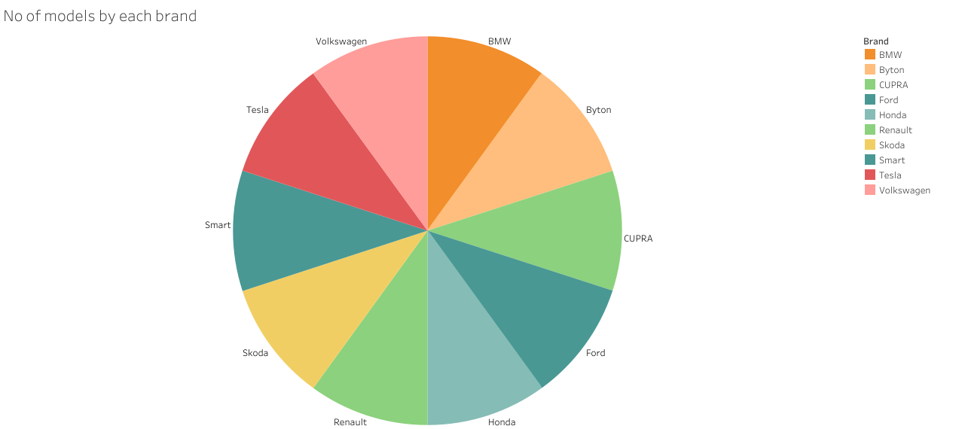 No of models by each brand

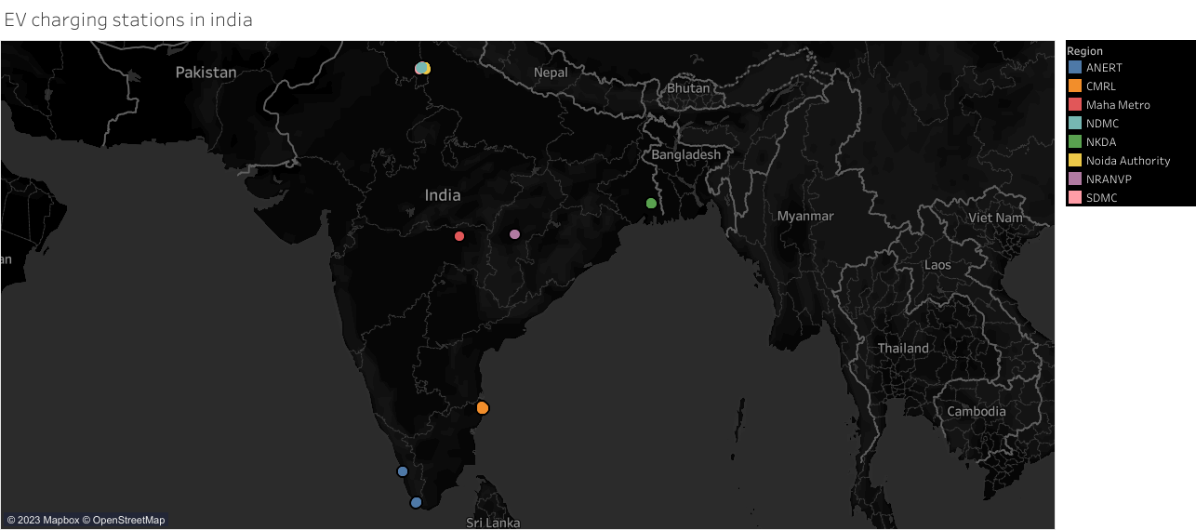

EV charging stations in INDIA

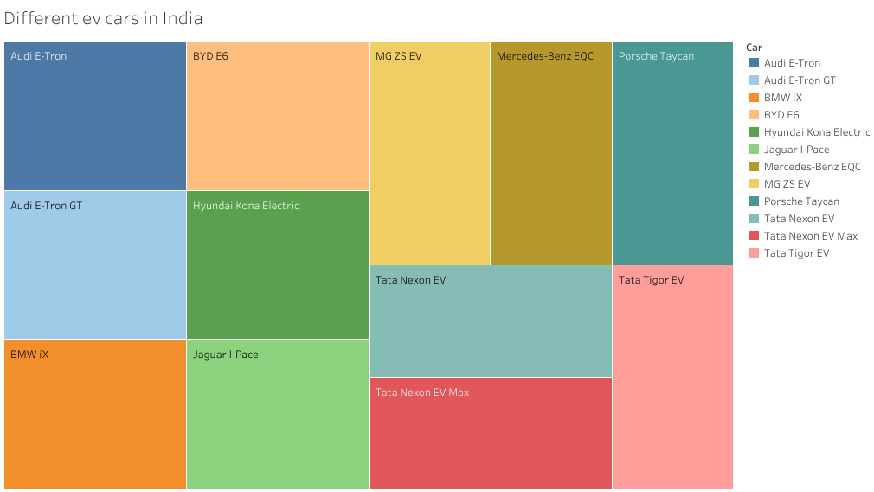

Different EV cars in INDIA



Different brands electric cars globally



Different car brands in INDIA

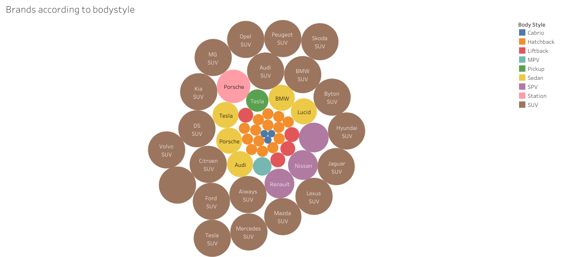

Brand according to bodystyle

**4. Advantages:**

Visualization tools can provide a clear understanding of how far an electric vehicle can travel on a single charge.

Visualization tools can help drivers understand how long it will take to charge their electric vehicles, allowing them to plan their charging schedules more effectively.

Visualization tools can help drives compare the cost of different charging stations, enabling them to choose the most cost effective option.

**Disadvantages:**

One potential disadvantage of using visualization tools for electric vehicle charges and range analysis is that accuracy of the data displayed may not always be reliable.Visualization tool may not provide a complete picture of the charging and range data .

It can lead to inaccurate predictions of how far an EV can travel on a single charge which can be frustrating or even dangerous for drivers who rely on this information.

It can make them accessible to the general public or to people who are not familiar with the intricacies of EV technology.

**5. Application;**

Visualization tools can help to visualize the SOC of the battery over time as well as how the range of the vehicle changes with different driving conditions.

It can help to identify patterns and trends in the data and to optimize driving strategies for maximum range.

Visualization can be used to map out the location and availability of charging stations as well as to analyze charging patterns and usage.

It can help to identify opportunities for reducing emissions and improving sustainability.

**6 .Future scope:**

As more EV hit the roads ,there will be an increased demand for electricity to power them .It could gather real time data on the charging status of EV as well as predictive analytics on range and battery health. This would enable users to plan their across different modes of transportation, optimizing ,their travel time and energy consumption.

**7. Conclusion:**

The electric charge and range of electric vehicles are highly dependent on several factors such as driving habits, terrain, weather, and vehicle specifications. The benefits of electric vehicles it is essential to have access to reliable charging infrastructure which will help to ensure that drivers can charge their vehicles as needed.

**8. Appendix:**

**i) Data sources:**

Charge point charging station data .Electric vehicle make and model specifications. Open street map for geospatial data.

**ii) Data analysis:**

Charge point charging station data was collected from their API. Electric vehicle make and model specifications were gathered from manufacturers websites and other reputable sources,

**iii) Data Preparation:**

Charge point charging station data was cleaned and filtered to remove any outliers and incomplete data .Electric vehicle make and model specifications were organized into a database for easy reference .Geospatial data was transformed into format compatible with the visualization tool.

**iv) Charge and cost calculator:**

Users can enter their electric vehicle make and model to calculate charging time and cost based on their current battery level and desired range.

**v) Range Visualization:**

Users can view the range of different electric vehicle models on a map with the ability to filter by make a model.